Skill - 1
Encapsulation Builder: Analyze the overhead introduced by protocol headers and determine how encapsulation affects network efficiency.
Aim: To capture network packets and understand how Ethernet, IP, and TCP/UDP headers are added during data transmission.
Whenever data travels through a computer network, each protocol layer adds its own header to the data. These headers introduce overhead. Using Wireshark, we will capture real network packets, examine Ethernet, IP and TCP/UDP headers, calculate the total overhead, and determine how efficiently the network carries application data.

Step – 1
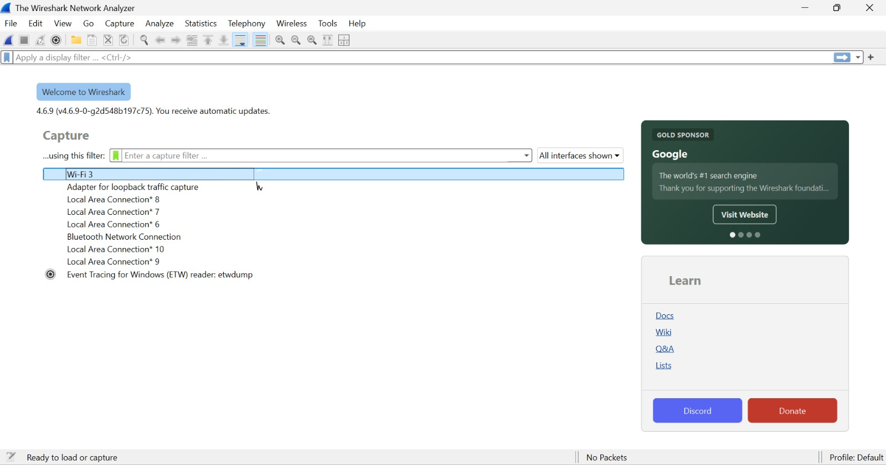
Step – 2
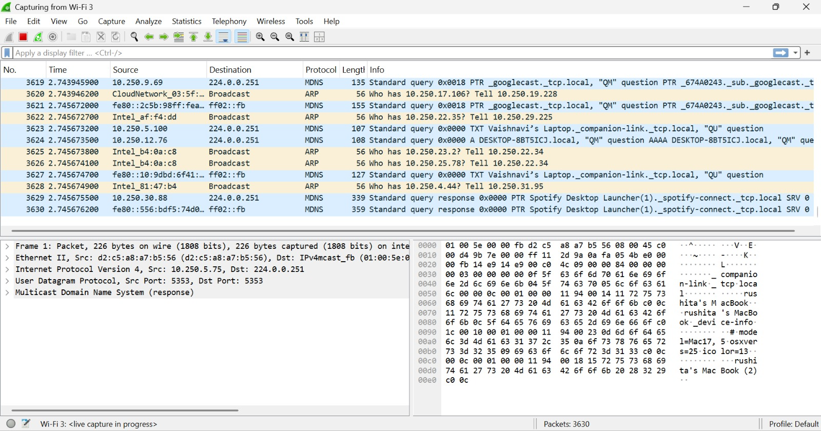
Step – 3
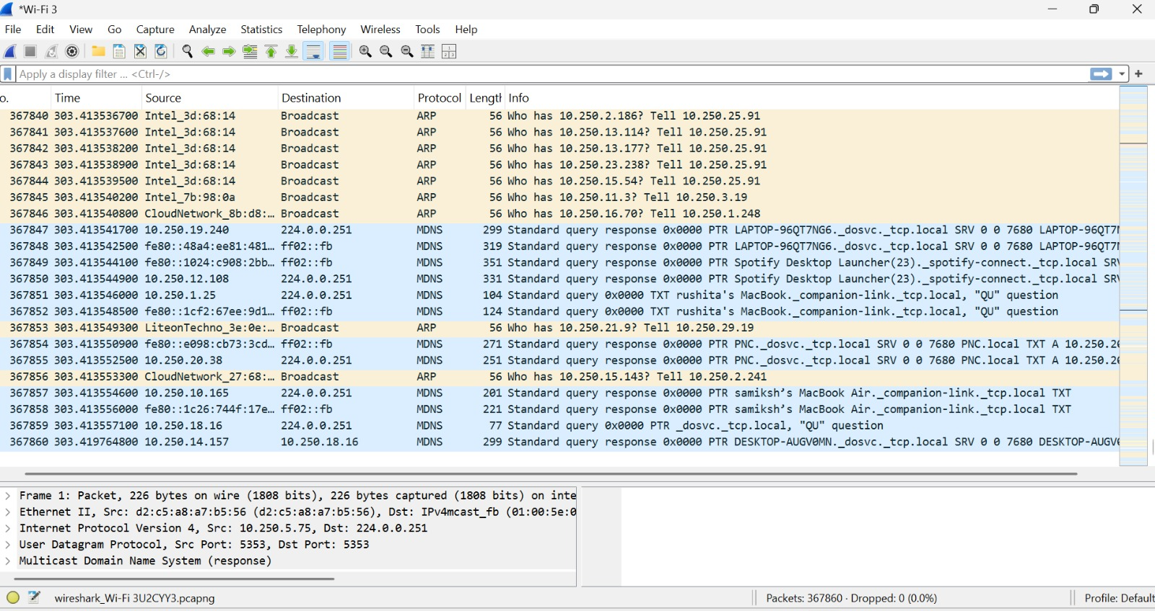
Step – 4
4.1
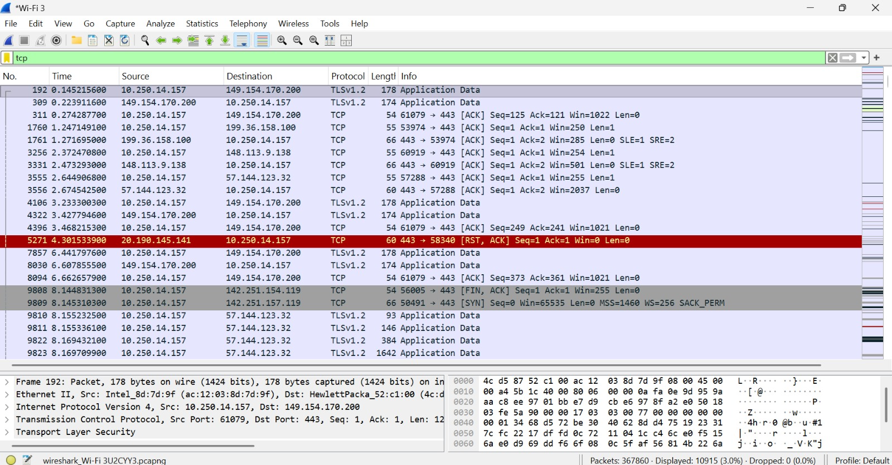
4.2
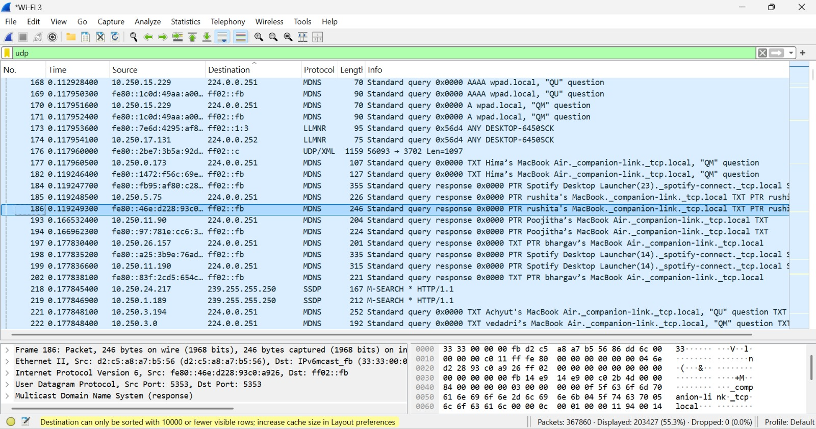
4.3
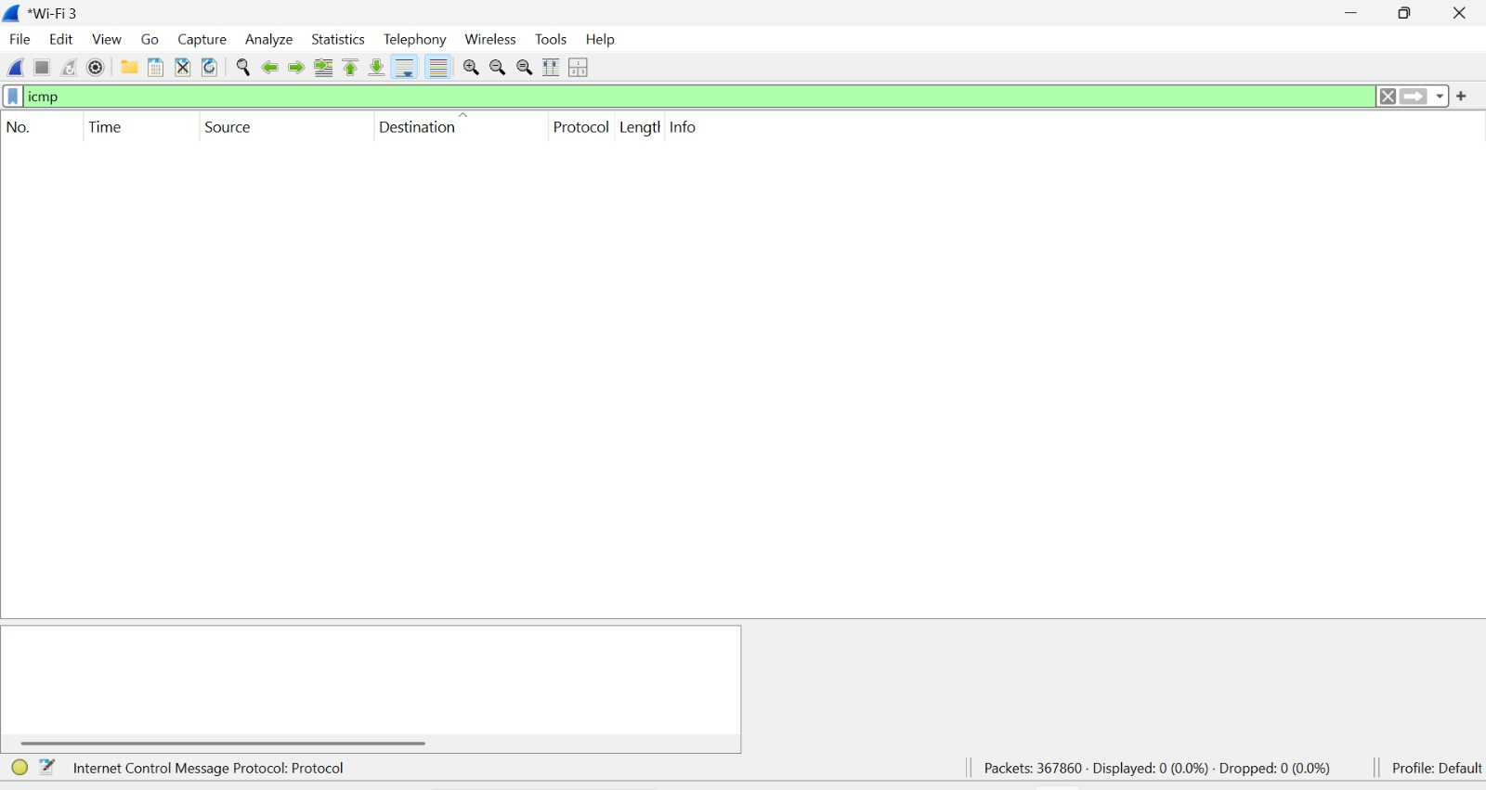
4.4
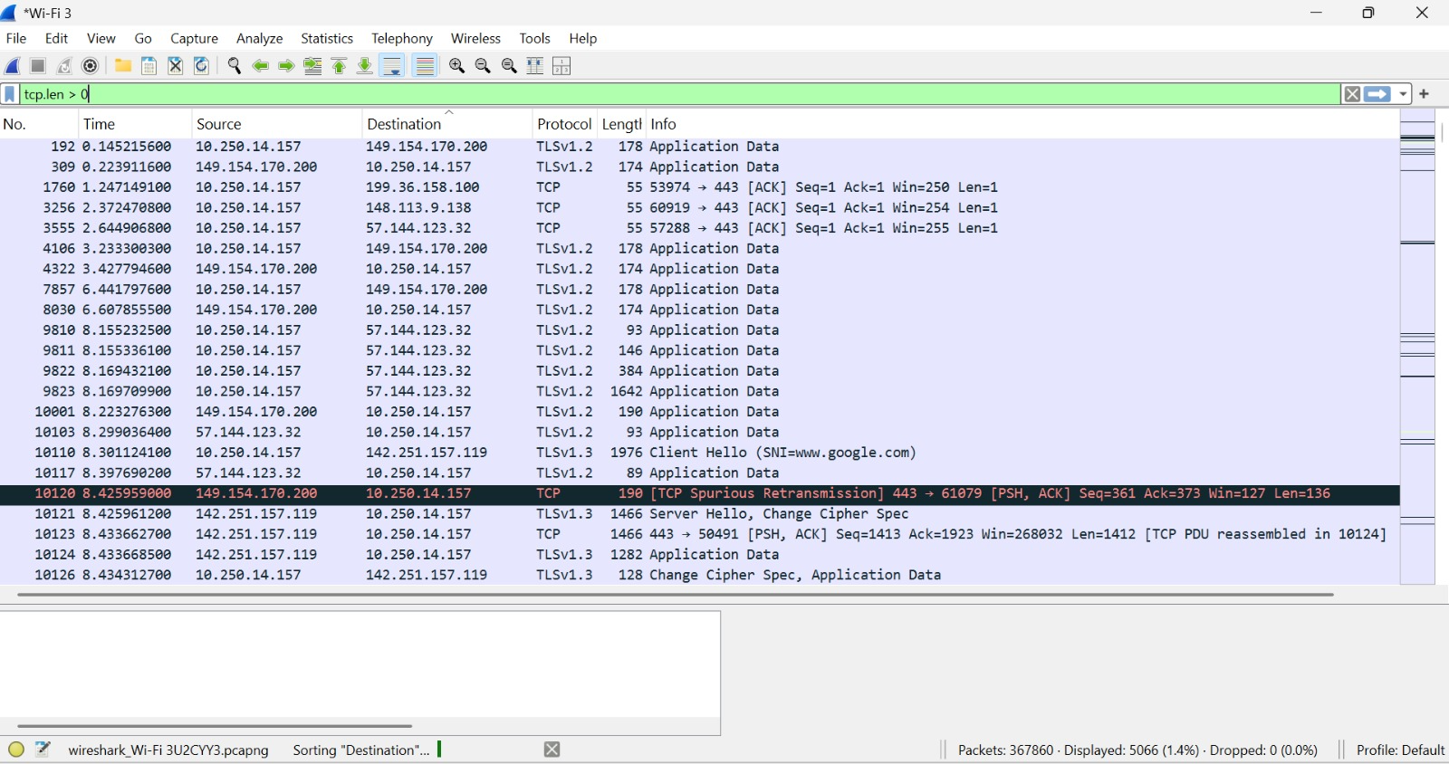
Step – 5
5.1
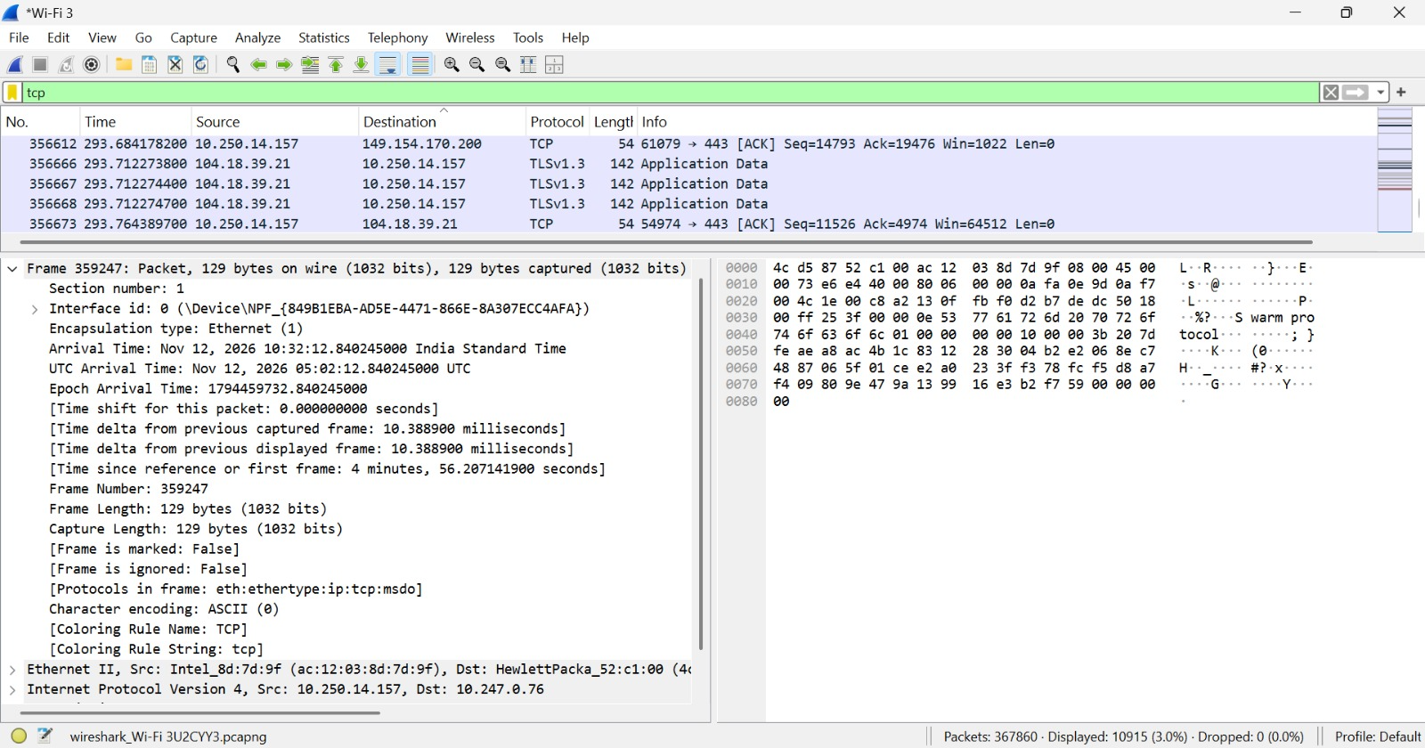
5.2
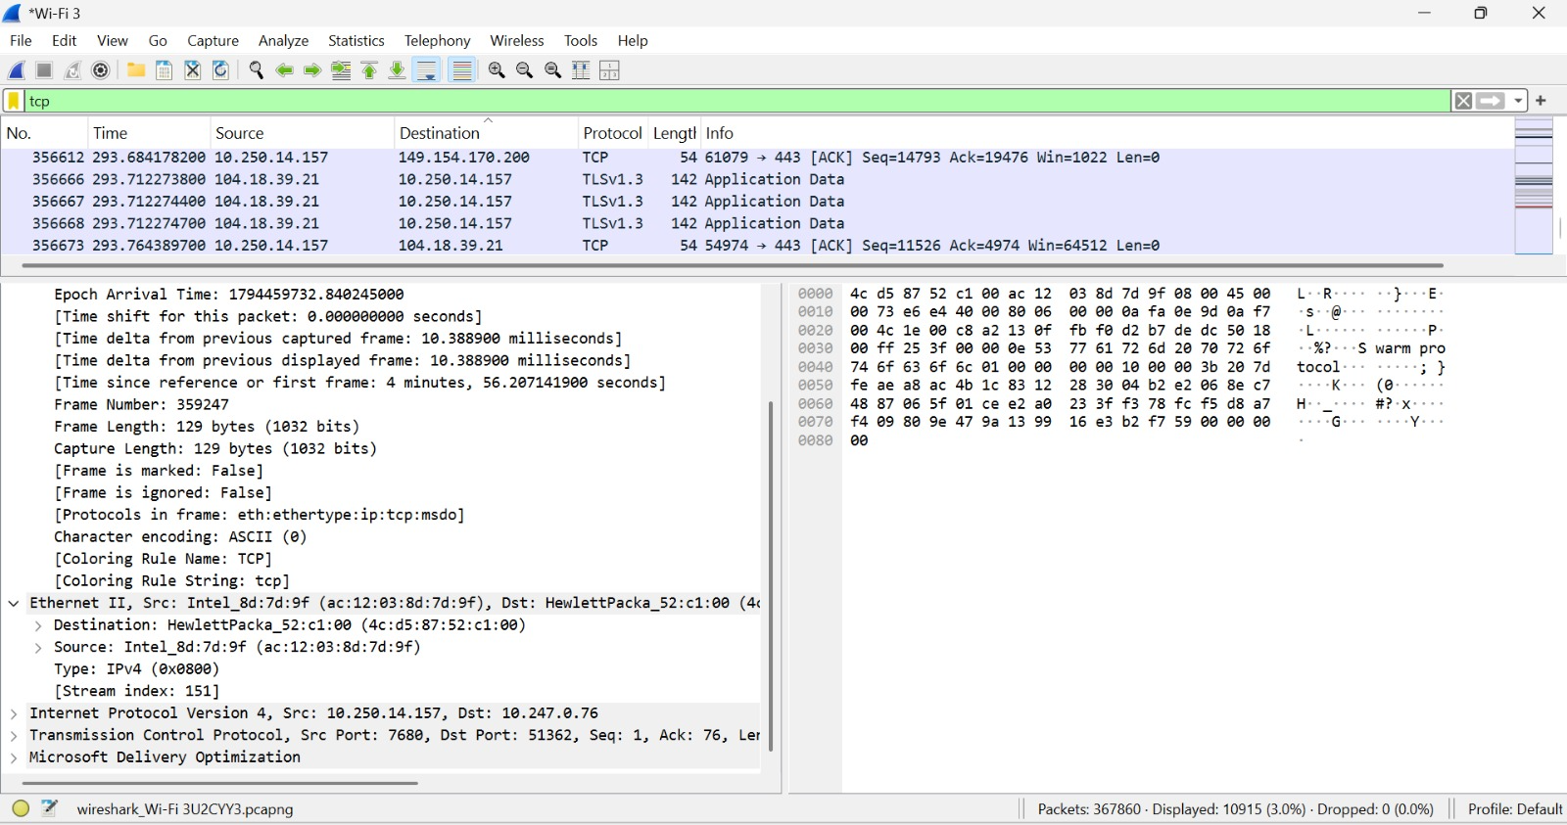
5.3
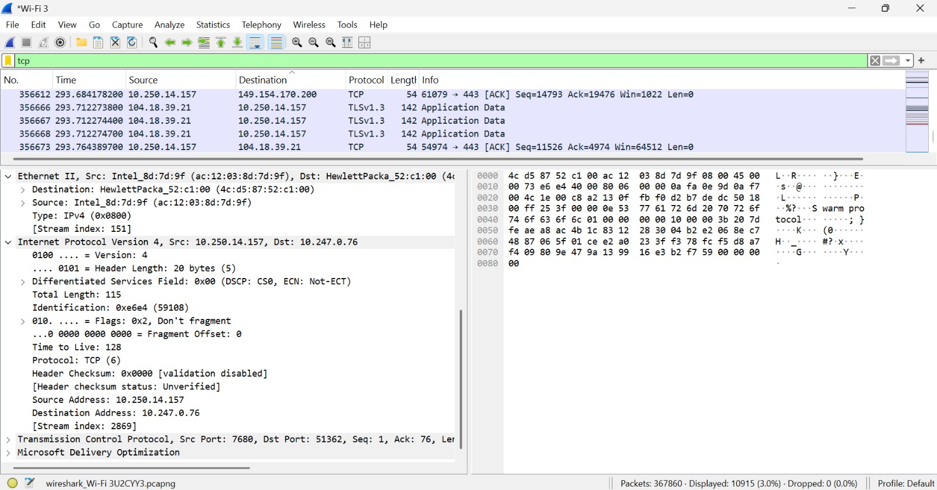
5.4
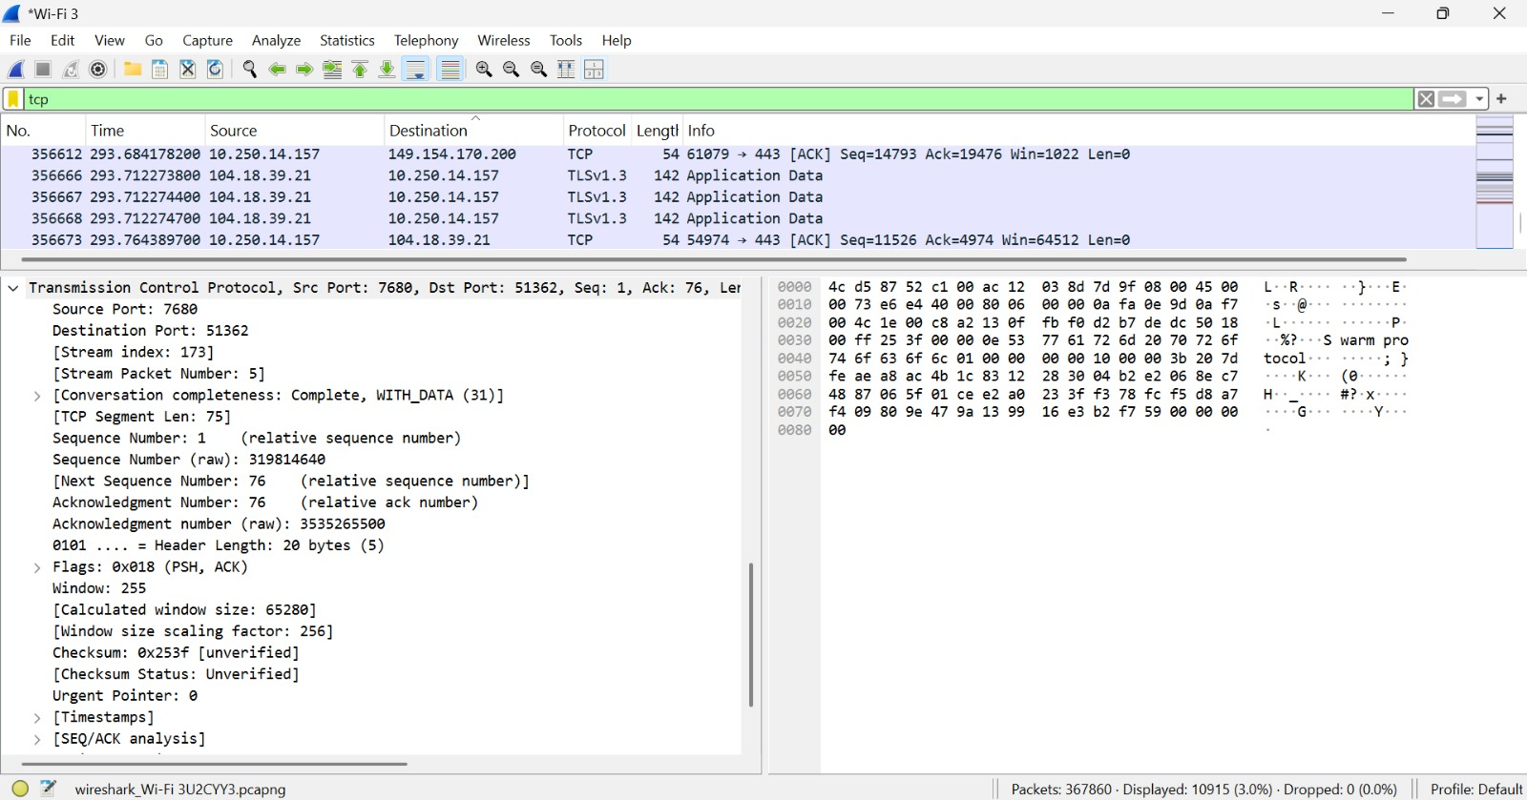
Step – 6
6.1
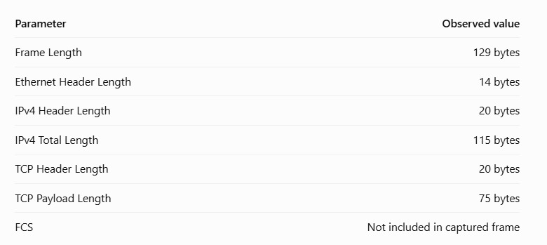
6.2 and 6.3
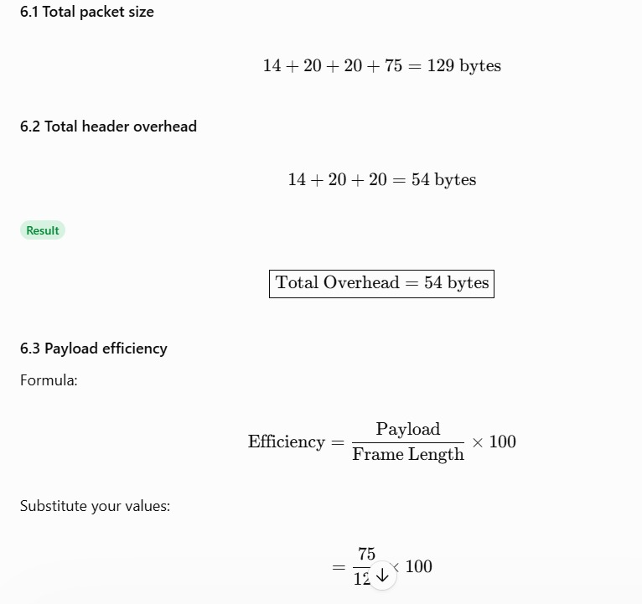
6.4
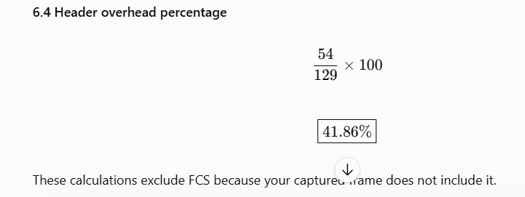
Step – 7


